THE CABLE ARM CLAMSHELL: DEVELOPMENT AND TRACK RECORD FOR ENVIRONMENTAL DREDGING

R.E. Bergeron, B.S. Cushing, and M.K. Hammaker

ABSTRACT

This paper examines the constraints imposed by environmental (remedial) dredging and some methods for dealing with them by use of an innovative dredge bucket, the Cable ArmTM clamshell bucket. Four of the most important of these constraints are: a) the need to minimize resuspension and downstream transport of contaminated sediment; b) the need for efficient and near 100% removal of the targeted material; c) the need to minimize the volume of water removed; and d) the need for precise removal of the targeted material with no or only minimum over dredging. As the field of environmental dredging developed during the 1990s, the Cable Arm bucket became recognized as a technology that offered the potential for improvement or relief in each of these four areas of constraint. The Cable Arm bucket is operated by steel cables and can be equipped with a full instrumentation package. The result is a large, level, rectangular and more precise cut as compared to a conventional bucket, and the potential for reducing resuspended sediments and entrained water.

The Cable Arm bucket is not an environmental dredging “cure-all.” Its effectiveness is dependent upon a trained and experienced operator, adherence to operational procedures, and suitable bottom conditions. Seven Case Histories are presented: Pickering Nuclear Station; Dow Canada (St. Clair River); Thunder Bay Harbor (Lake Superior); Ford Outfall (River Raisin); Dupont Newport Superfund Site (Christiana River); Terry Creek; and Saginaw River/Bay.

KEYWORDS: case histories, innovative dredge, level cut, removal efficiency, resuspension control

INTRODUCTION

Environmental (remedial) dredging introduces constraints and sensitivities not present in navigation or maintenance dredging and the need for new and innovative equipment and procedures to deal with these constraints. This paper examines these constraints and some methods for dealing with them by use of an innovative dredge bucket, the Cable ArmTM clamshell bucket. The Cable ArmTM bucket has attracted widespread interest and is now establishing a track record on environmental (remedial) dredging projects. The bucket's development, its design features and operating methods for environmental dredging as well as its use for navigation dredging, and its performance on environmental dredging projects to-date is presented.

ENVIRONMENTAL DREDGING CONSTRAINTS

Environmental, or remedial, dredging is characterized by a number of constraints and sensitivities not present for navigation dredging. Four of the most important of these constraints are summarized below:

- The need to minimize resuspension and downstream transport of contaminated sediment. Resuspended, contaminated sediment not only becomes available to be swept downstream and become a source of contamination to downstream areas, but also can fall back onto the dredged surface, making attainment of low contaminant cleanup levels more difficult.

- The need for efficient and near 100% removal of the contaminated target material. The complete and efficient removal of contaminated sediment is often difficult to achieve, particularly when using either a conventional clamshell bucket, which tends to produce potholes, or a hydraulic dredge, which can leave furrows or windrows. Inefficient removal methods lead to the need for multiple passes with the dredge to maximize removal of contaminated sediment. This inefficiency can result in significant amounts of contaminated material being left behind or failure to achieve low cleanup target levels, or both.

- The need to minimize the volume of water removed, since (a) excess water in the payload adds to the disposal volume and cost and (b) all water from an environmental dredging project must typically be collected and treated prior to discharge. Water treatment equipment not only produces an additional project cost but also a production constraint -- often causing periodic shut down of a hydraulic dredging operation due to under capacity (inability of the water treatment process to keep pace with the volume of water produced by the hydraulic dredge).

- The need for precise removal of the targeted material with no or only minimum over dredging, since each cubic yard of material removed is typically handled as contaminated and represents a high cost liability for handling and disposal.

As the field of environmental dredging developed during the 1990s, the Cable Arm bucket became recognized as a technology that offered the potential for improvement or relief in each of these four areas of constraint. For example, the innovative design and operational procedures associated with a Cable Arm bucket have essentially eliminated sediment loss from the bucket during lowering and raising and reduced sediment resuspension upon bucket placement, closing, and initial lifting. Constraints No. 2 and 3 (above) are naturally compensated for by the fundamental design and method of operation of the bucket. Constraint No. 4 is addressed by the level, rectangular cut and by the addition of improved instrumentation for positioning the bucket and monitoring the depth of cut.

DEVELOPMENT OF THE CABLE ARM BUCKET

When Ray Bergeron of Cable Arm, Inc. set out to design a better clamshell bucket in 1989, he was initially focusing on bulk material handling. In his shop in Trenton, Michigan, he designed and constructed a bucket operated by cables and produced a large footprint and level cut. The bucket, with its relatively light weight and durable steel construction, offered the potential for a larger capacity bucket to be used for a given crane capacity. The “Cable Arm” bucket design was patented in 1989. This first bucket was used for bulk grain unloading.

Subsequently, it became apparent that the Cable Arm bucket had potential for navigation dredging of unconsolidated sediments (the bucket does not have conventional “bucket teeth”). The opening, cut, and closing of the Cable Arm clamshell bucket is controlled by two steel cables. One cable controls the opening of the bucket using four spreader chains to guide the two sideplates as they open. The second cable controls bucket closure and lifting and operates through a series of cantilevered sheaves to allow closure of the two sideplates at a slow, controlled rate. A tag line (chain) connected between the bucket and the crane maintains bucket alignment, i.e., prevents the bucket from spinning. To minimize downward water pressure during descent of the open bucket through the water column, vents in each sideplate open and allow water and trapped air to escape. The sideplates open to nearly 180°and, with the bucket’s “floating pivot” action, produce a larger, level, rectangular cut -- eliminating the pothole effect produced by a conventional bucket. For example, a conventional 6 cy capacity clamshell would produce a footprint of about 60 ft.² (10 ft. x 6 ft.) while a similar capacity Cable Arm bucket would produce a 144 ft.² (18 ft. x 8 ft.)4 footprint. Figures 1 and 2 depict Cable Arm buckets.

The first navigation dredging performed using a Cable Arm bucket was at two projects in 1992, using crane-mounted seven and eight cubic yard buckets, respectively. Reportedly, both the larger footprint and the level cut led to more efficient dredging and increased production rates on these two projects, as compared to a conventional bucket of similar capacity. Subsequently, environmental (remedial) dredging applications for the Cable Arm bucket were evaluated and implemented.

FEATURES

Before reviewing case histories, the features of the Cable Arm bucket that make it particularly suitable for environmental dredging are summarized.

- The lighter weight of the Cable Arm bucket, as compared to a conventional bucket, is a result of its manufacture with high strength steel and the absence of counter weights (the sideplates swing open under their own weight). The lighter weight allows for optimal bucket payload for a given crane capacity.

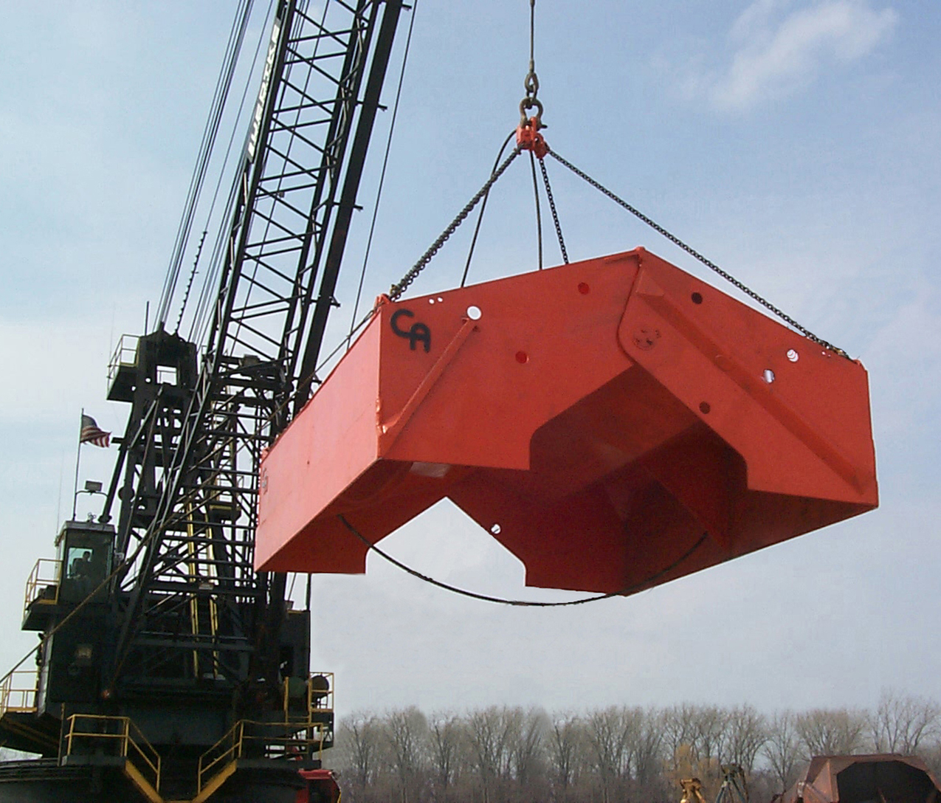

Figure 1: Cable Arm bucket (15 cy capacity) to be used at Saginaw River/Bay in 2000

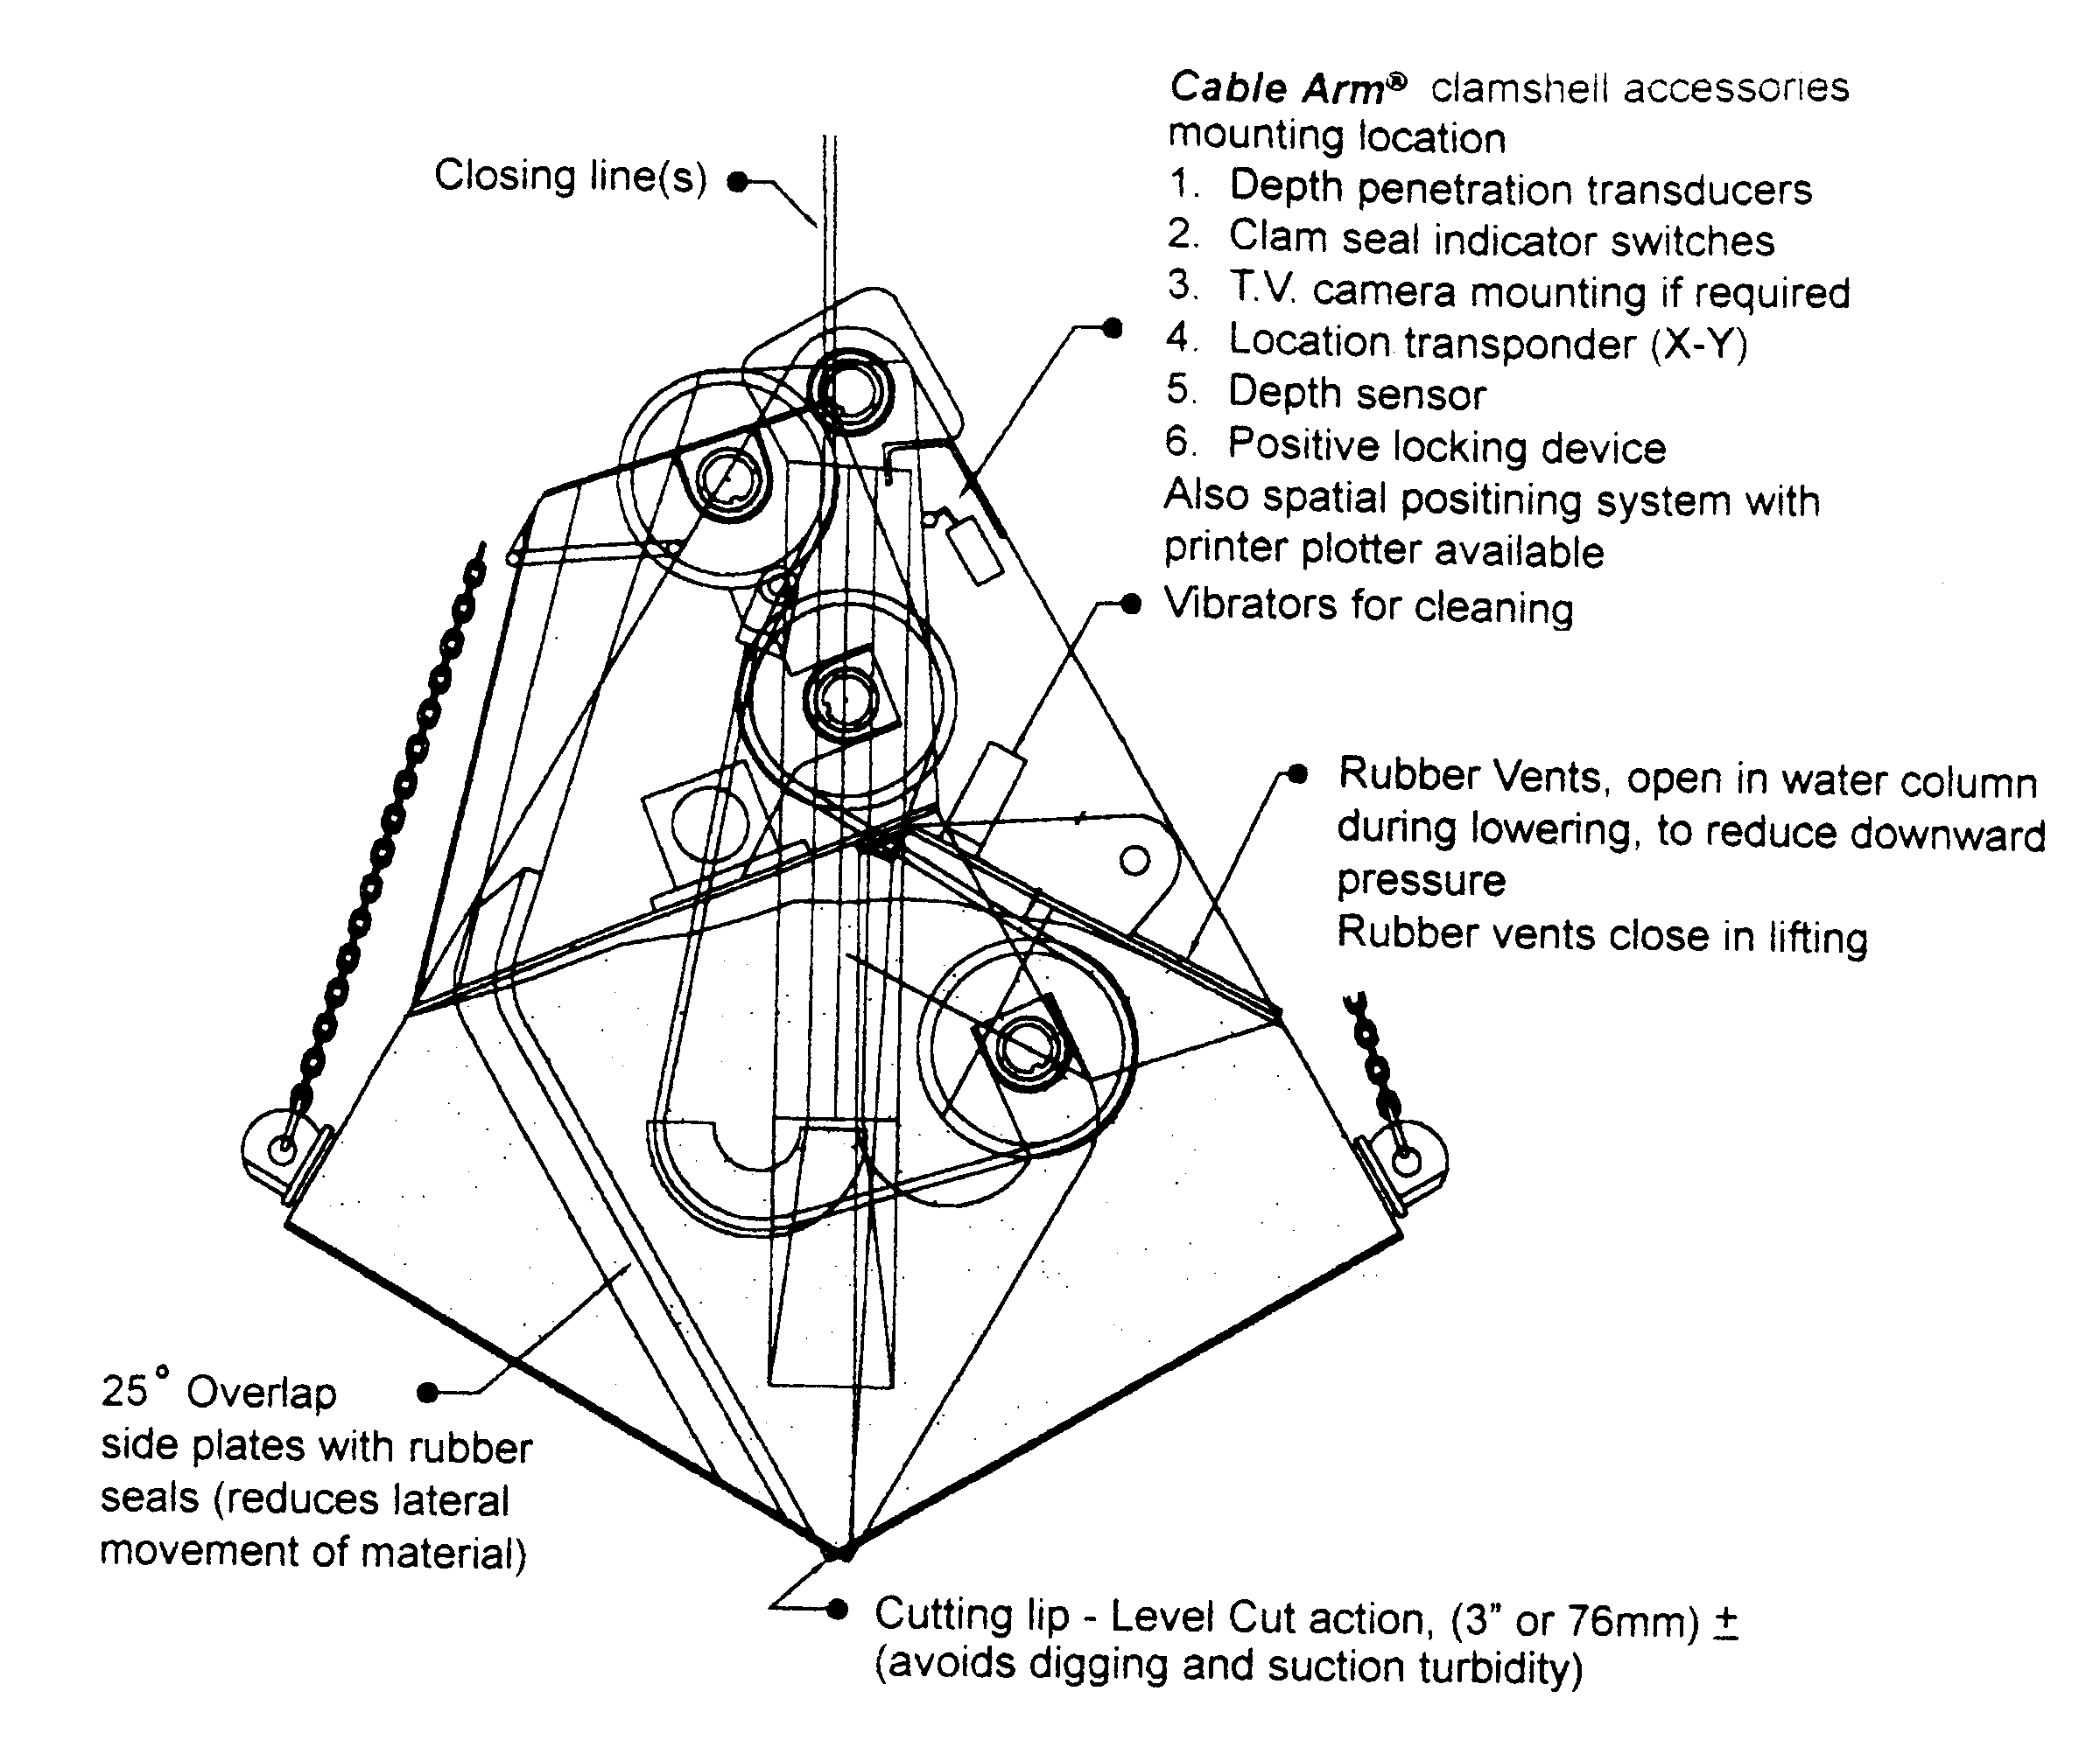

Figure 2: Schematic of Cable Arm Clamshell Bucket

- Vents in each sideplate automatically open on descent to minimize downward water pressure and therefore minimize turbulence ahead of the bucket, which could produce movement and resuspension of the unconsolidated bottom sediment. The same vents automatically close on ascent, to prevent loss of dredged material.

- The impact of the Cable Arm bucket into the unconsolidated target material is substantially less than that from a conventional bucket. The shape of the cut and the level cut closing action combine to minimize suction in the footprint as the bucket is closed or lifted. Further, only about the lower 25% of the sideplates are in contact with the sediments during closing. All of these factors serve to minimize resuspension of sediments. Depth of cut can be controlled within  3 inches.

- The sideplates, with rubber seals, overlap by about 25% upon closing. An overlap seal light goes “on” to indicate complete closure of the bucket to the operator. The overlap helps eliminate windrowing of sediment and provides additional protection against loss of dredged material during ascent and during the swing to the discharge location. An additional benefit of the overlap is the tendency for debris to be deflected upon closure.

- The design and operation of the bucket allows the mounting of computerized sensors and data recording devices on the inside of the sideplates. Data such as total suspended solids (TSS), pH, temperature, turbidity, and conductivity can be obtained in real time during the movement of the bucket in the water column. Additionally, a bucket-mounted control and monitoring system is available, which can include echo-sounders, pressure transducers, video cameras, and a light source all connected to display monitors in the crane cab or other centralized location. The control and monitoring system provides the crane operator and construction oversight personnel with data on water depth, depth of bucket penetration, swing and boom angles, and target area mapping (which can be made compatible with GPS positioning systems and tide gauges).

- At the water surface on ascent, the unmixed, minimally-contaminated water trapped above the sediment payload is allowed to drain out of the bucket through the sideplate vents, decreasing the amount of water in the payload and increasing the solids to water ratio.

- The bucket can also be equipped with pneumatic vibrators that, when activated, aid in dislodging material from the bucket when the bucket is opened for discharging.

- Following discharge of the payload but before deployment of the bucket into the water for the next cut, a wash cycle should be implemented. After discharge, there will typically be a thin coating of dredged (contaminated) material adhering to the inside surfaces of the bucket and solid material in the corners. If not removed, this material could become resuspended when the open bucket is next lowered through the water column. Instead, the material should be removed by submerging the open bucket in a wash tank with the vibrators activated (if so equipped).

LIMITATIONS

The Cable Arm bucket is not an environmental dredging “cure-all.” Its effectiveness is dependent upon a trained and experienced operator, adherence to operational procedures, and suitable bottom conditions. For example, its relatively light weight and absence of cutting teeth limit its use to removal of unconsolidated material. Although unconsolidated material removal is the norm for navigation dredging, and, of course, for bulk material handling, environmental target areas present a wide range of locales and bottom-material consistency.

Target Area Limitations

Firstly, environmental (contaminated) target areas are often areas that have never been dredged before, unlike harbors and navigation channels, and may be characterized by the presence of debris, vegetation, and rocks. These obstacles present continuous problems for hydraulic dredging, and can be a hindrance to clamshell dredging. Secondly, environmental target areas may either be unconsolidated or consolidated sediment areas and also may be characterized by the presence of bedrock (usually with an irregular surface) at a shallow depth below the sediment surface. Although the Cable Arm bucket would be appropriate for use only in unconsolidated sediment target areas, it is not unreasonable to expect the majority of environmental dredging projects to fall in this category. In this regard, it is appropriate to note several problematical factors facing project stakeholders when selecting target areas for remediation, namely:

- Targeting removal of unconsolidated, contaminated sediments can be justified in instances where it is demonstrated that (a) the sediments are a potential or continuing source of contamination to the surrounding water body and to biota (fish) and (b) a removal can be performed which is sufficiently efficient not to redistribute contaminants into the surrounding water body to an unacceptable extent and not to expose long-buried contaminants and leave residual contamination on the dredged surface. In other words, there needs to be a valid scientific reason for the removal and the removal itself must be efficient, with resuspension of sediment minimized.

- Targeting removal of consolidated, contaminated sediments may be a questionable strategy. Contaminants may be sequestered, adsorbed into the sediments, and unlikely to be or ever become a source of contamination to the surrounding water.

- Accomplishing efficient and complete removal of contaminated sediments at a bedrock or natural till interface using either a hydraulic or clamshell dredge is a futile undertaking. Surface resistance and irregular contours deflect the dredge head. Reference (Cushing, 1998 and 1999) re the GM Massena project in the St. Lawrence River and Manistique River/Harbor project in Michigan.

Operational Procedures and Cycle Time

Adherence to operational procedures established by Cable Arm, Inc. is crucial to maximize environmental dredging efficiency with the Cable Arm bucket. The operational procedures are aimed at achieving a precise, level cut that maximizes payload with minimum impact on water quality (i.e., minimizing resuspension of contaminated sediments and loss of payload on closure and ascent and loss of residual materials from the bucket on descent). The operational procedures increase cycle time as compared to navigation dredging protocol, an obvious source of concern to cost-conscious contractors. However, the constraints imposed by environmental dredging demand longer cycle times, which are not unique to the use of a Cable Arm bucket. What should be paramount is the use of equipment and procedures, which avoid a financial penalty to the client due to removal and disposal of excess material, maintain water quality within acceptable limits during dredging, and minimize the resuspension and uncontrolled distribution of contaminated sediment.

Operational procedures for a Cable Arm bucket which tend to increase the cycle time, but which, for most environmental projects, should not be ignored include:

- Dropping the bucket at a rate not exceeding 1 foot per second, to avoid creating excessive water pressure ahead of the bucket.
- Use of real time instrumentation control to position (X-Y) the bucket over the target area and control the depth of cut (Z). A pause over the target area is typically required for the X-Y digital display to stabilize.
- Avoiding overfilling the bucket with sediment (which can subsequently be released through the sideplate vents during water draining).
- Not lifting the bucket until complete closure is confirmed (by the positive seal indicator light).
- Slowly lifting the bucket and its payload to the surface, stopping with sideplate vents positioned just above the water line, and allowing the relatively uncontaminated water above the payload to drain from the vents.
- Lifting the bucket from the water, positioning the bucket over the receiving scow or container, and partially, then fully opening the bucket for discharge, with vibrators activated (if so equipped).
- Moving the open bucket over and into the rinse tank with vibrators activated.

With these procedures, the efficiency of the Cable Arm bucket should be maximized. Cycle times on previous projects have ranged from about three up to eight minutes, however, cycle times in the three to four minute range should typically be achievable in nominal water depths.

Resuspension Control

As the Case Histories (below) demonstrate, the Cable Arm bucket has satisfactorily met water quality limitations imposed by each completed project. However, it is fair to point out that water quality monitoring on the great majority of environmental dredging projects to-date has tended to be simplistic. Single probe, periodic water quality monitoring for a single parameter (e.g., turbidity) provides a very limited picture of the extent of resuspended contaminants. Conversely, intensive, multi-point, multi-parameter water quality monitoring and sampling around and downstream of a dredging area is manpower intensive, time-consuming, and costly. A compromise needs to be struck on environmental dredging projects regarding quantity and frequency of monitoring and sampling and the important water quality parameters need to be defined with more precision on a project-specific basis.
The simplest measurement of resuspension is turbidity, which can be measured in real time by a probe. Turbidity readings may provide a means of locating and tracking a plume, but provide no quantitative measure of solids or contaminant concentrations. More informative measurements such as TSS, particle size fractions, and individual contaminant concentrations cannot be measured in real time and vary spatially in three dimensions in the water around a dredging area. In some instances, caged fish have been deployed during dredging and subsequently analyzed as a measure of resuspended contaminants lost. The means for controlling resuspension operationally, and the interpretation of data, is complex and still not well understood. Some references that have addressed this subject include (Database, 2000; van Oostrum, et al., 1994; and Committee, 1997).

A step in the right direction in addressing this dilemma can be the use of an environmental bucket such as the Cable Arm bucket with close adherence to the prescribed operational procedures, coupled with enough multi-location, periodic sampling events to demonstrate compliance with water quality limitations early in the project - - with spot-checking thereafter or as changes in the conditions or location of the target area warrant.

CASE HISTORIES

Pickering Nuclear Station - Ontario

(This Case History summary is excerpted from Environment Canada, 1997.) The first environmental dredging application of the Cable Arm bucket was in 1993 at Pickering B Nuclear Generating Station in Ontario for removal of sediment and debris from on top of a new sediment bypass system. For protection of the nuclear station, it was vital to minimize resuspension during the removal so as not to impact a nearby cooling water intake. A primary current flowed from the removal area toward the intake. Entrainment of resuspended material into the water intake could lead to derating of the nuclear plant and possible shutdown. Ontario Hydro selected the Cable Arm bucket for the removal, and rejected conventional mechanical buckets and hydraulic dredges due to concerns with the amount of resuspension and the need to manage excess water. Ontario Hydro requested a methodical ten minute cycle time be employed initially.

A 3.2 cy capacity Cable Arm bucket was used, equipped with an underwater camera and depth transducer. About 200 cy of sediment and debris were removed. Overall, cycle time averaged eight minutes. Initially, overfilling of the bucket occurred due to operator inexperience in using the bucket and transducer, causing exceedance of the TSS limit of 22 ppm (10 ppm above ambient at 80 feet from the dredge). Subsequently, as experience was gained, TSS exceedances stopped. The project was completed with no negative effects on station operation and reactor safety.

Dow Canada (St. Clair River) – Sarnia, Ontario

(This Case History summary is derived from information in Knauss and Nettleton, 1999 and Cable Arm, 1998.) In September 1995, a 0.1 acre area of discolored, soft, tar-like material was discovered in the St. Clair River about 100 feet offshore and immediately downstream of the Cole Drain (a municipal discharge). Subsequent analyses identified a suite of contaminants including volatile and semi-volatile hydrocarbons and chlorinated benzenes. Hexachlorobutadiene (HCBD), a semi-volatile chlorinated hydrocarbon, was present in percent levels. Depth of contamination in the sediment ranged from inches to 1.6 feet. Dow Canada subsequently volunteered to remove and dispose of the contaminated sediment, using a Cable Arm clamshell bucket recommended by Environment Canada. The Cable Arm bucket was selected for this project over such other candidate dredge technologies as an Ellicott Mud Cat, a Pneuma Pump dredge, the Amphibex combination dredge, diver-assisted vacuum removal, and a conventional bucket dredge.

The cleanup of the 0.1 acre area was successfully accomplished to a visually clean standard, verified by divers, and indicated by the presence of the underlying gray clay layer. A total volume of 225 cy was removed in 220 bucket lifts over a period of eight days in May 1996. Cycle time, as measured from the time of bucket submergence to the time of its removal from the water (the only measure documented), ranged from 2 to 6 minutes. The 0.1 acre target area had been gridded in advance in a pattern of bucket-sized rectangular grids, with cut dimensions defined and allowing for a one-foot cut overlap. (For future reference, one lesson learned is that it would have been more efficient to key the grid patterns to the crane radius and not to a parallel array.)

For this environmentally sensitive, localized removal of heavily-contaminated sediments, the Cable Arm bucket was equipped with and relied on the following instrumentation:

- Two video cameras and a light source in the bucket, to identify debris and assess the cut;
- Two video monitors at the control station, one for each video camera;
- A pressure transducer for water depth measurement;
- An echo sounder, to measure depth of cut into the sediment;
- A switch, with signal light in the control station, to verify bucket closure and seal;
- A sonar scanner mounted on the downstream end of the crane barge, which provided a constant scan of the sediment surface; and
- Two computer stations in the control room, one for recording cut depths and bucket volumes and one for maintaining X-Y plot locations and any changes made to the grids as the project progressed.

Two tiers of water monitoring were performed during the removal operation. For the first tier, two water quality parameters were monitored at two locations, just upstream of the dredge and 130 feet downstream, as a measure of acceptability of the dredging operation on water quality. Turbidity was monitored by lowering a probe into the water column, with the downstream measurements keyed to either visible plume observance or timed to coincide with the bucket cycle. Perchloroethylene was monitored using on-line gas chromatographs. The dredging operation was to be halted if turbidity exceeded river background by 5 NTU over five minutes or if perchloroethylene concentrations exceeded 10 ppb. Increases in turbidity were detected during some dredging cycles, but did not result in halting of the dredging operation. No exceedances of the perchloroethylene concentration were measured.

For the second tier of water monitoring, Environment Canada performed extensive and detailed water monitoring at different depths for trace organics analysis of individual chemical constituents as well as TSS and other basic water parameters. The purpose of this second tier monitoring program was to provide sufficient data (not on a real time basis) for an extended analysis of contaminant releases during dredging and for use in sediment transport model analyses. The findings are described in detail in Knauss and Nettleton, 1999. Several interesting findings relative to the impact of the dredging operation in the St. Clair River follow:

- “During the six days of dredging monitored by the Ministry, no available drinking water levels or objectives for chlorinated aliphatics and aromatics and polychlorinated dibenzo-p-dioxins and dibenzofurans, or aquatic life acute toxicity thresholds were exceeded in any of the water samples collected.”

- The previous statement not withstanding, “there were short-term adverse impacts on St. Clair water quality” as evidenced by the detection downstream of a variety of the sediment contaminants at concentrations above background.

- “Although slight elevations in turbidity were detected during the dredging cycle, turbidity levels as well as suspended solids concentrations were not a sensitive enough measure of the impact of the dredging operation; however, concentrations of the major chlorinated contaminants found in the sediment were.”

- “The contaminant mass released or lost to the river, relative to the contaminant mass removed by the dredging, was calculated to be about 0.1 to 1.3%. While this implies a high “removal efficiency” (i.e., of about 98.7 to 99.9%) by the Cable Arm Clamshell dredge, it also illustrates that removal efficiency alone is a poor indicator upon which to make a decision regarding any future dredging operation, particularly for toxic chemical ‘hot spots’. Although this efficiency may be significantly better than that of other conventional dredging methods, it may not be sufficient to prevent adverse downstream impacts, as indicated by short-term excessive concentrations of persistent, toxic and bioaccumulative chemicals within the water column, and high loadings to the river system.”

These findings indicate on the one hand that the Cable Arm bucket performed effectively and within the constraints imposed on the dredging operation and on the other hand emphasize the complexity of evaluating and managing resuspension effects, as discussed earlier in this paper.

Thunder Bay Harbor - Lake Superior, Ontario

(This Case History summary is derived in part, from information in Hun, 1997, “A Special Challenge,” 1998; and ETV Canada Technology Fact Sheet.) In 1997, a 6 cy Cable Arm clamshell bucket (15 ft. x 9 ft. footprint) was selected to remove contaminated sediments from the Northern Wood Preservers site in Thunder Bay Harbor in Lake Superior, a designated Great Lakes Area of Concern. For over 50 years the site was used for wood preserving operations resulting in significant contamination of nearshore surface sediments in the harbor. Primary contaminants were creosote (a dense nonaqueous phase liquid that collected at the sediment-water interface and, based on 20 years of studies, was adversely impacting fish and other organisms), pentachlorophenol, and dioxins and furans. In some areas, sediments were found to contain nearly 50% by volume of creosote.

Cleanup of the site was performed as a cooperative effort involving three industrial partners, Ontario=s Ministry of the Environment and Energy, and Environment Canada. The selected strategy for remediating the site was implemented as a multi-stage plan called the Northern Wood Preservers Alternative Remediation Concept that included removal of the most highly contaminated sediments. Project specifications for sediment removal required the use of a closed environmental clamshell bucket with a cut line capability of 3 inches and the use of an X-Y-Z positioning system to control bucket placement. The Cable Arm bucket was selected. The decision was based on the ability of the Cable Arm bucket to meet these criteria with its proposed precise, controlled, level cut and optional bucket-mounted control and monitoring system that greatly increases the accuracy and precision of bucket placement.

Dredging of nearshore sediments in 1997 resulted in the removal of 13,000 m³ (17,000 cy) of creosote-contaminated sediments. The average cycle time was 3 minutes (a bucket wash operation was not used, resulting in a reduced cycle time). A one-foot overlap was used during bucket placement (yielding an equivalent 13 ft. x 7 ft. footprint). Following removal, the remedial plan required that sediment be treated at an estimated cost of $100-400 per ton depending on the treatment technology selected. The high cost for treatment of the removed sediments placed particular emphasis on minimizing the removal of excess sediment. The ability of the Cable Arm bucket to dredge to specified depths was independently verified during the removal.

Challenges specific to the project which affected both the efficiency and quality of the completed project included:

- Significant debris (logs) from a previous log processing facility required removal;
- Creosote contamination softened cable rubber on instrumentation
- Ice buildup developed on sensors due to cold ambient temperatures (the bucket was kept below water at night to prevent bucket sensors from icing over);
- The crew had not been trained to function in an environmental dredging project;
- The crane was unsuitable for precision dredging, with no speed control up or down; and
- The silt curtain was of questionable suitability and suspended solids monitoring was only performed sporadically.

Ford Outfall (River Raisin) – Monroe, MI

(This Case History is derived from information in Database, 2000 and Metcalf & Eddy, 1998.) In 1993, the USEPA targeted a 2.6 acre hot spot in the River Raisin for a Non-Time Critical Removal Action. The hot spot was located adjacent to the Ford Monroe Plant and was shown to be contaminated with an area weighted average concentration of 3,020 ppm PCBs. The targeted area was about 750 feet long by 150 feet wide and located between the shore and navigational channel. Water depths ranged from 4-6 feet nearshore, increased due to a rapid steep slope to 15-18 feet, then increased to 30 feet in the navigational channel. The hot spot was divided into 14 sub-areas to provide a more systematic approach for the removal operations. The Cable Arm bucket was selected by the contractor following a successful demonstration. The Cable Arm bucket was equipped with a full array of positioning and parameter monitoring instrumentation and its use was aimed at minimizing wastewater generation as well as downstream turbidity levels. The contractor elected to eliminate the use of the wash tank on this project.

Removal of 28,500 cy of sediment took place over a three month period from June to September 1997. The 2.6 acre targeted area was bordered by 3,000 linear feet of silt curtain; an inner silt curtain was deployed around the sub-area. A 3900 crane on a barge with first a 4 cy and subsequently a 6 cy Cable Arm bucket were used to remove sediments to as deep as 6 feet below the initial sediment surface. Removal was supplemented by a conventional clamshell bucket for rock and debris removal and for some Ahard till@ target areas along the break in slope. In addition, a 3.5 cy slim-profile Cable Arm bucket was used to offload sediment from the receiving scow to gasketed dump trucks for transfer to a temporary storage area, prior to stabilization and landfilling. Water column monitoring for PCBs was performed during the first week of dredging, concurrent with the existing turbidity monitoring program. The water column monitoring was subsequently discontinued because the action levels to trigger additional monitoring were not exceeded. Sediment verification samples were collected in each of the 14 sub-areas following initial dredging, the results indicating that contaminated sediment remained above the river bottom cleanup level of 50 ppm in 8 sub-areas and above the side slope cleanup level of 10 ppm at the side slope-river bottom interface.

Subsequently, as described in (Meltcalf & Eddy, 1998):

“(The Contractor) immediately initiated re-dredging in dredge-cells not meeting the cleanup goal. The date of October 1st was identified as the deadline for completing re-dredging and moving of the silt curtain, since the river closure posted under the Local Notice to Mariners would expire and a commercial shipment was planned. The environmental clamshell bucket was used in dredge-cell areas with remaining sediment of greater depth. The environmental clamshell bucket, being gasketed, was also used in dredge-cell areas with deposits of sediment from resuspension. In such areas, the dredging cycle-time was increased in order to minimize resuspension. A conventional clamshell bucket was used along the base of the sloped drop-off since it was a narrower bucket. The conventional bucket was efficient in picking up narrow pockets of sediment that were missed during prior dredging from along the break in slope.”

“Confirmatory sample collection activities in many dredge-cells were revealing that sediment remained, even though prior dredging to refusal had occurred. A review of information from dredging, sampling and the dive inspection for the silt curtain identified the following suspected sources of remaining sediment:

- A 0-3 foot layer of sediment deposited due to the passage of an unauthorized lake freighter;
- A 0-0.5 foot layer of sediment deposited following resuspension during dredging;
- 0-2 foot thick pockets of sediment along the base of the slope comprising the drop-off in the Sediment Removal Area (SRA) from the nearshore shelf to the dredged channel; and

- Sloughing of sediment outside of the SRA into the SRA along the base of the silt curtain.”

“It was further reported that the redredging effort went essentially to bedrock. Often, the remaining sediment being dredged consisted of a 2-6 inch layer of highly liquid sediment. The redredging effort was assisted by diver inspections.”

Following redredging, half of the areas contained insufficient sediment to collect a verification sample. In the remaining seven sub-areas, PCB levels ranged from 0.5 to 20 ppm. The project generated about 725,000 gallons of wastewater requiring treatment, equating to a low 25 gallons of wastewater generated per cubic yard of sediment removed.

This project clearly illustrates the inherent difficulty in meeting low cleanup levels when attempting to remove sediment to a hard, irregular surface (as previously noted in this paper), and in controlling sediment resuspension and movement within the dredge area. Also illustrated is the capability of the Cable Arm bucket, when operated according to specification, to minimize the generation of wastewater.

Dupont Newport (Christiana River) - Wilmington, DE

(This Case History summary is derived, in part, from information in Database, 2000.) Three sediment hot spots located in a 1.5 mile stretch of the Christiana River in Delaware were identified by USEPA for removal. The hot spots contained an estimated 10,000 cy of sediment contaminated with metals and solvents at levels considered toxic to benthics. The river is tidally influenced and bordered by industrial facilities and two industrial landfills in the vicinity of the hot spots. The Superfund Record of Decision specified the use of a hydraulic dredge for removing sediment from the river, with special emphasis on minimizing the transport of suspended sediment from the dredge area, including using silt curtains to surround the dredge area. The responsible industry for the cleanup instead specified a Cable Arm clamshell bucket instead of a hydraulic dredge to further reduce resuspension during dredging. In addition, sheet piling was installed around the full perimeter of each hot spot (excluding one small obstructed area inaccessible to the sheetpile installation equipment) to provide additional control of the transport of resuspended material from the dredge area.

The performance of the Cable Arm bucket was found to be unsatisfactory for use on the majority of hot spot sediments due to the following factors:

- Since the entire perimeter of each hot spot was sheetpiled, concerns about downstream transport of suspended material and downstream turbidity were greatly diminished.

- Sediment in the hot spot areas was insufficiently characterized prior to the start of dredging; following the start of dredging, the hot spots were found to contain much higher volumes of consolidated material than was previously known. The higher than anticipated stream flow velocities prevailing in the target areas were consistent with areas exhibiting consolidated bottom sediments.

- The Cable Arm bucket was unable to efficiently remove the consolidated material, resulting in higher unit costs on a per volume basis to the contractor.

These factors resulted in the contractor replacing the Cable Arm bucket with a backhoe on a barge after approximately two weeks and removal of only 200 cy of sediment.

This project clearly highlights the importance of complete and accurate characterization of sediment prior to the selection of equipment for its removal in addition to emphasizing that the Cable Arm bucket is designed for removal of unconsolidated materials

Terry Creek – Brunswick, GA

(This Case History summary is derived from information in Database, 2000.) The Terry Creek site is located near the confluence of Terry Creek, Dupree Creek, and the Back River and includes an Outfall Ditch, areas of Dupree Creek (the receiving stream) and Terry Creek (which Dupree Creek flows into after 0.4 miles). These water bodies are contaminated with toxaphene (a pesticide) that originated from a nearby industrial facility discharge pipe that historically emptied into the east end of the Outfall Ditch. Levels of toxaphene in Outfall Ditch sediments were measured as high as 30,000 ppm. In 1997-1998, the USEPA and the responsible industry signed an agreement to perform an emergency removal action of sediment from the Outfall Ditch, three areas in Dupree Creek and areas in and near the confluence of Dupree Creek and Terry Creek. The entire area is tidally influenced, with the average tidal range being about 7.5 feet. A 150-ton crane equipped with a 6 cy (9 ft. x 12 ft. footprint) Cable Arm bucket was selected by the contractor for removal of sediments from areas of the Outfall Ditch not accessible by long-reach excavator and for removing creek hot spot sediments. The Cable Arm bucket was selected because of its flat, horizontal footprint, as well as to minimize wastewater generation (which the contractor was responsible for) and turbidity levels during dredging. The project work plan specified mass removal of the contaminated sediment to a specified depth interval depending on the area to be dredged. The Outfall Ditch depth interval varied from 1-8 feet; the depth interval for the creek hot spots was 1 foot.

Sediment removal began in August 1999 and is on going. It is anticipated that 90% of the mass of toxaphene will be removed by this project. Originally scheduled for completion in October 1999, sediment removal is now scheduled to be completed in Spring 2000. A total of 21,500 cy have been removed to-date. The longer project schedule is primarily attributable to the inherent challenges of working in tidally influenced waterways. The large tidal swings have significantly affected the ability of the contractor to move barges to and from the unloading area. This has limited the availability of empty barges for receiving further sediment and, in turn, the time available for dredging. Sediment removed using the Cable Arm bucket is being loaded onto 300 cy hopper barges for transport to an unloading area and subsequent disposal in drying beds. Water draining from the drying beds is returned to the Outfall Ditch after passing through silt fencing and a sand trench to remove solids. Use of the Cable Arm bucket has greatly reduced the volume of water generated and required for treatment over that which would have been generated if the alternative method of dredging, hydraulic, as provided in the Request for Bid, had been selected.

Water monitoring for turbidity and contaminant levels during dredging has consisted of collecting aliquots of water every 20 minutes from immediately outside the downstream portion of the turbidity curtain for rapid analysis at an on-site laboratory. Periodically samples are being sent to an off-site laboratory for confirmation analysis. No levels above the site action levels for turbidity or toxaphene (non-detect) have been measured to-date from the samples, indicating that the Cable Arm bucket is minimizing the release of suspended materials during the removal operation.

Saginaw River/Bay – Saginaw, MI

(This Case History summary is derived, in part, from information in Database, 2000.) The Saginaw River/Bay is one of the Great Lakes Areas of Concern. Five priority segments in a two-mile sector of the lower Saginaw River, totaling about 53 acres, are targeted for remedial dredging beginning in April 2000 and finishing by November 1, 2000. The project involves the removal of an estimated 350,000 cy of PCB-contaminated sediments with concentrations ranging up to 34 ppm. The sediment will be loaded onto barges for transport to the existing confined disposal facility in Saginaw Bay. The project will reportedly remove an estimated 80% of the PCB mass present in the Saginaw River.

The US Army Corps of Engineers, in the Construction Solicitation and Specification for this project, (Corps, 1999), included explicit requirements for the type of equipment to be used to remove sediment from the river, stating in part:

“Prior to bringing equipment to the project site, submit plans of the proposed dredging, conveyance and disposal operations including environmental bucket manufacturer’s name, model number and size.”

“The environmental bucket shall be a gasketed clamshell or similar design, Cable Arm or equal, with a proven field performance record, which shall preclude loss of material between point of excavation and placement in scows.”

In addition, the project specifications do not allow for bucket dragging or over dredging and require that a bucket rinsing operation be included in the bucket cycle, all elements presently part of Cable Arm’s standard operating procedures for environmental dredge projects. A 15 cy capacity (16 ft. x 18 ft. footprint) Cable Arm bucket equipped with a full array of positioning and monitoring instrumentation (including tide compensated depth controls) has been selected for the project. The bucket, for the first time, has been designed to provide a wider than longer footprint, allowing for increased footprint overlap (side-to-side) depending on the depth of cut at each bucket target location. In addition, an 8 cubic yard Cable Arm bucket will be used at the disposal site to offload the sediment from the barges to dump trucks for transport to the disposal cell.

According to the Construction Specification, turbidity and water quality monitoring will be closely monitored during dredging. Each of the five targeted areas are to be fully enclosed with silt curtain, extending from the water surface to the river bed where it will be anchored, prior to the start of dredging. Three monitoring stations are to be established for each area, located halfway between the shoreline and Federal Channel limit. One station will be located 300 feet. upstream from the boundary of the silt curtain in the area being dredged for collection of background turbidity measurements and water samples. The other two stations will be located at 300 feet and 600 feet downstream from the boundary of the silt curtain. Turbidity measurements will be collected at both downstream stations while water samples for PCBs will be collected daily only at the 300 feet station. After the first week of dredging, water samples for PCB analysis will be collected only when/if the turbidity action level is reached (or at the lead Agency’s discretion). Should downstream turbidity exceed the upstream background turbidity levels by 50% or more, the contractor will be required to cease dredging and introduce corrective procedures.

The Cable Arm bucket will be equipped for the first time with a modified WINOPS dredge positioning software system to guide the removal of contaminated sediment on the project. The WINOPS system will provide the following capabilities:

- Positioning of the crane derrick barge in an X-Y graphic display in real time to any scale with heading in State plane coordinates;
- Providing the operator an accurate geodetically oriented image of the bucket footprint and crane boom during digging operations at a maximum of one-second intervals. This image is to be located using State plane X-Y coordinates;
- Superimposing bucket targets with individual designations over the derrick image at any scale to assist the operator in placing the bucket over each target for complete coverage;
- Providing a cross section display depicting the area template and showing the bucket depth with history in real time; and
- Logging pertinent data to allow replay of the entire job graphically and showing the X-Y-Z position of the bucket the same as real time.

WINOPS PC based dredge software will provide the crane operator with a geodetic image of the crane barge, spuds, derrick circle, boom and bucket and will be used with three DGPS receivers to complete derrick positioning and orientation. WINOPS will also be used to provide the operator with a precise image and orientation of the bucket during real time dredging operations. In addition, a radial dig pattern (RDP), created by entering the bucket footprint, boom angle and angular separation between bucket targets, will be used. RDPs are developed by superimposing individually numbered bucket targets over the derrick image to give the operator a concise picture of each bucket position. A two-foot side to side and set overlap is input to the RDP to provide complete coverage of the removal area.

SUMMARY

Seven case histories reviewed show that the Cable Arm bucket successfully met the dredging criteria on four of the projects despite the presence of typical environmental dredging constraints; two of the projects are still underway; and on one project the bucket proved inappropriate due to consolidated bottom conditions. Cycle times on completed projects ranged from 3-8 minutes, longer than for standard navigational dredging, but necessary to ensure proper operation and to manage the constraints and sensitivities unique to environmental dredging.

Special site-specific considerations are required for environmental dredging projects during the planning and design phase regardless of the technology selected for sediment removal. Prerequisites to environmental dredging should include:

- a properly characterized dredge area;
- use of engineers and contractors previously experienced in environmental dredging;
- confirmation (either project specific or from prior experience) of applicability of proposed equipment, instrumentation, and monitoring;
- selection of criteria and format for data logging;
- a dredge plan to include: definition of target area, depth of removal (specified depth or to bucket refusal), and acceptable residual contaminant levels; operational requirements; contingency procedures for debris removal and handling; and the selection of monitoring locations relative to removal equipment location;
- a monitoring plan discussing type, extent, and frequency of monitoring/sampling and shutdown criteria;
- equipment specifications (e.g., crane capability for precision dredging); and
- a training plan for field crews and essential site personnel.

The success of the Cable Arm bucket to reduce both the generation of resuspended material and wastewater during the dredge cycle is making it a preferred technology for environmental dredging projects in unconsolidated sediments. Recently, for several projects, specifications have stated that the Cable Arm bucket, if not specifically selected, provides the project standard to which other sediment removal technologies will be compared.

REFERENCES

“A Special Challenge,” Great Lakes/Seaway Review. January-March 1998.
Cable Arm, Inc. (1998), Video of St. Clair River Project, Dow Canada Project.
Committee on Contaminated Marine Sediments (1997), "Contaminated Sediments in Ports and Waterways: Cleanup Strategies and Technologies," National Academy Press, Washington, DC.
Corps of Engineers, Detroit District (1999), “Environmental Dredging: Saginaw River/Bay, Michigan: Construction Solicitation and Specifications,” DACW35-99-B-0005.
Cushing, B.S. (1998), "Remediation of Sediments by Dredging: Methods and Case Histories," Proceedings of the Fifteenth World Dredging Congress, Las Vegas, NV.
Cushing, B.S. (1999), "Capping: The "Other" Method of Sediment Remediation: Status and Case Studies," Proceedings of the Western Dredging Association Nineteenth Technical Conference, Louisville, KY.
Environment Canada (1997), "Remediation Technologies," Great Lakes 2000 Cleanup Fund.
ETV Canada, “LEVEL-CUT™ Clamshell Bucket – Cable Arm (Canada) Inc.,” Environmental Technology Verification (ETV) Program – Technology Fact Sheet.
Hun, (1997), “Cooperative Remediation Initiative Underway in Thunder Bay Harbor,” Water Environment & Technology.
Knauss, P.B. and Nettleton, P.C. (1999), "Impact of 1996 Cole Drain Area Contaminated Sediment Cleanup on St. Clair River Water Quality," ISBN 0-7778-8598-0, Ontario Ministry of the Environment.
Major Contaminated Sediment Sites Database (2000), Release 2.0, General Electric Company, Applied Environmental Management, Inc., Blasland, Bouck & Lee, Inc., http://www.hudsonwatch.com.
Metcalf & Eddy, Inc. (1998), “Completion of Removal Action/Completion of Work Report for River Raisin Sediment and Soil Removal,” prepared for US EPA, Region V.
van Oostrum, R.W. and Vroege, I.P. (1994), "Turbidity and Contaminant Release During Dredging of Contaminated Sediment," Proceedings of the Second International Conference on Dredging and Dredged Material Placement, Lake Buena Vista, FL.

Bergeron, R. E., President, Cable Arm, Inc., Trenton, MI, 734-676-6108, 734-676-1345 (fax), info@cablearm.com.
Cushing, B. S., V. P. and Principal, Applied Environmental Management, Inc., Malvern, PA, 610-251-0450, 610-251-0711 (fax), bcushing@aem-inc.com.
Hammaker, M. K., Sr. Project Engineer, Applied Environmental Management, Inc., Malvern, PA, 610-251-0450, 610-251-0711 (fax), mhammaker@aem-inc.com.
4 Cable Arm has constructed similar capacity buckets with varying footprint areas. Six cy buckets also produce 108 ft² (12 ft. x 9 ft.) and 135 ft² (15 ft. x 9 ft.) footprint areas.

